**React Native Notes**

**1) Installation - Windows**

1. Download & install Java SDK - For any android apps

2. Download & install Node JS - To generate application bundle & package management

3. Download & install Python2

4. Android Studio

5. React Native Command Line Tool - npm install -g react-native-cli

6. Initialize a project - react-native init [projectName]

7. Open android studio and open the existing project.

8. Tools - Android - AVD Manager

9. Set Environment Variables

JAVA_HOME - C:\Program Files\Java\jdk-version

Path - C:\Users\[username]\AppData\Local\Android\sdk\platform-tools

10. Open cmd from Project directory. Run react-native run-android

11. Set up ESLint

1. npm install -g eslint

2. Install package Control - packagecontrol.io/installation

3. ESLint config - npm install --save-dev eslint-config-rallycoding

4. Create a .eslintrc file in root project directory

{

"extends" : "rallycoding"

}

5. Install sublime linter - CTRL+Shift+P in sublime - Install Package - sublimelinter, sublimelinter-contrib-eslint

**2) Getting started with the Project**

1. index.android.js and index.ios.js are the entry files to our applications. When the app first starts, it will execute all of the code in these files.

index.android.js

//Import a library to help create a component

import React from 'react';

import ReactNative from 'react-native';

//Create a component

//Render it to the device

**3) Differences between React and React Native**

**React** - Knows how a component should behave. Knows how to take a bunch of components and make them work together.

**React Native** - Knows how to take the output from a component and place it on a screen. Provides default core components (image, text)

**4) Create a component with JSX - babeljs.io**

//Create a component

const App = () => {

return (

<Text>Some Text</Text>

);

};

**5) Registering a Component**

//Render it to the device

ReactNative.AppRegistry.registerComponent('[projectname]', () => App);

*[projectname] should match with the name of our project directory name.

*For every React application that we create, we must register atleast one component.

**6) Destructuring Imports**

import { Text, AppRegistry } from 'react-native';

const App = () => (

<Text>Some Text</Text>

);

AppRegistry.registerComponent('[projectname]', () => App);

**7) The Header Component**

* Always create one component per file.

* Create a new folder - src - components

* Create a new file. Eg - header.js

* Only the root component uses 'AppRegistry'

//Import libraries for making a component

import React from 'react';

import { Text } from 'react-native';

//Make a component

const Header = () => {

return <Text> Albums! </Text>

};

//Make the component availabe to other parts of the app

export default Header;

**8) Consuming File Exports**

*Component Nesting - Add Header component to App Component

import Header from './src/components/header';

const App = () => (

<Header />

);

**9) Styling with React Native**

const Header = () => {

const { textSyle } = styles;

return <Text style={textStyle}> Albums! </Text>

};

const styles = {

textStyle : {

fontSize : 20

}

};

*View Tag - More like a wrapper

import { Text, View } from 'react-native';

const Header = () => {

const { textStyle, viewStyle } = styles;

return (

<View style={viewStyle}>

<Text style={textStyle}> Albums! </Text>

</View>

);

};

const styles = {

viewStyle : {

backgroundColor : '#F8F8F8'

},

textStyle : {

fontSize : 20

}

};

**10) Introduction to Flexbox**

**\*justifyContent** - Position elements in the vertical direction

**\*alignItems** - Position elements in the horizontal direction

justifyContent : 'flex-end', 'center', 'flex-start'

alignItems : 'flex-end', 'center', 'flex-start'

const styles = {

viewStyle : {

backgroundColor : '#F8F8F8',

justifyContent : 'center',

alignItems : 'center',

height : 60,

paddingTop : 15,

shadowColor : '#000',

shadowOffset : { width: 0, height: 2},

shadowOpacity : 0.2,

elevation : 2,

position : 'relative'

},

textStyle : {

fontSize : 20

}

};

**11) Reusing Components - props**

const Header = (props) => {

const { textStyle, viewStyle } = styles;

return (

<View style={viewStyle}>

<Text style={textStyle}> {props.headerText} </Text>

</View>

);

};

//index.android.js

const App = () => (

<Header headerText={'Albums'} />

);

**12) Sourcing Data - Album Data here**

* First we need an API or so, from where we could retrieve the data - http://rallycoding.herokuapp.com/api/music_albums

* Let's have two components - Album List and Album Detail

Album List will render several Album Details components

**13) List Component Boilerplate**

* Create a new file for AlbumList Component - AlbumList.js

import React from 'react';

import {View, Text} from 'react-native';

const AlbumList = () => {

return (

<View>

<Text>Album List!!!</Text>

</View>

);

};

export default AlbumList;

* We cannot return two components in App. It's like

return 1;

return 2;

* When we have multiple tags to be returned, we can tag them inside a single View Tag.

//index.android.js

import { AppRegistry, View } from 'react-native';

import AlbumList from './src/components/AlbumList';

const App = () => (

<View>

<Header headerText={'Albums'} />

<AlbumList />

</View>

);

**14) Class Based Components - Making an HTTP request**

* All the components we made so far are functional components. They are functions that return some amount of JSX to be displayed.

* Differences between Functional and Class Based Component

|  |  |
| --- | --- |
| **Functional Component** | **Class Component** |
| Used for presenting static data | Used for dynamic sources of data |
| Can’t handle fetching data | Handles any data that might change (fetching data, user events, etc) |
| Easy to write | Knows when it gets rendered to the device (useful for data fetching)  More code to write |
| const Header = ( ) => {  return <Text>Hi There!</Text>  } | class Header extends Component {  render () {  return <Text>Hi There!</Text>  }  } |

**15) Lifecycle Methods**

* Class based components have the advantage of Lifecycle methods.

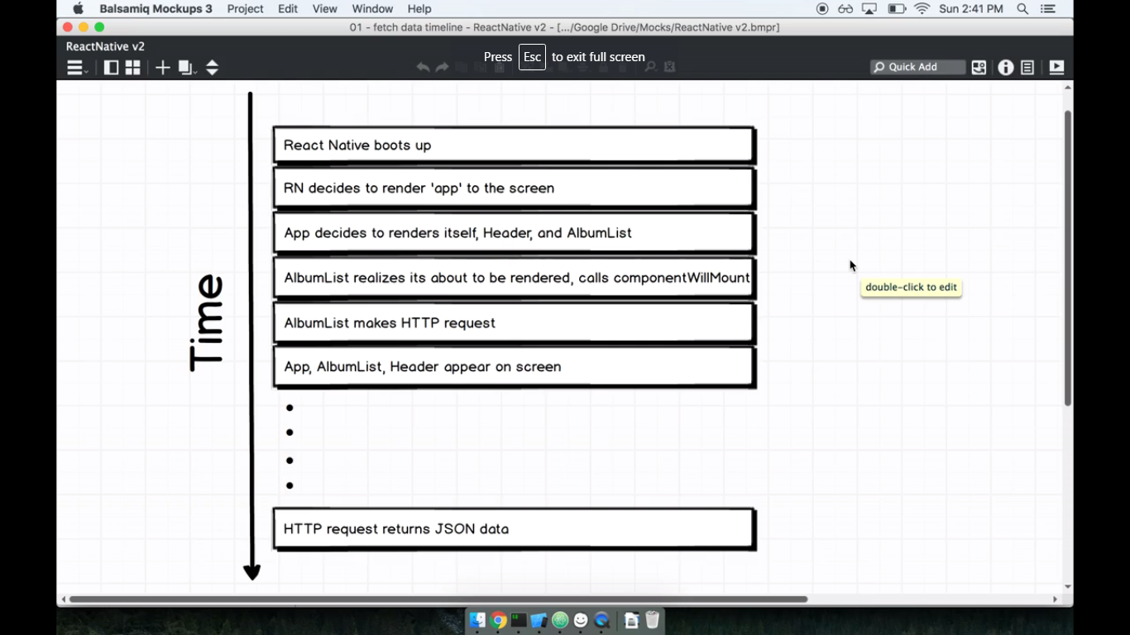

**1) componentWillMount()** - Anytime the component is about to be rendered to the screen, this method will be automatically called. We can initiate data loading process to the component here.

class AlbumList extends Component {

componentWillMount () {

console.log("componentWillMount");

}

render() {

return (

<View>

<Text>Album List!!!</Text>

</View>

);

}

}

*To debug the code, we use the built-in debugger in react native. In the Emulator, press CTRL+D - Debug JS Remotely. We can also use debugger statement.

**16) Network Requests**

* We have to install Axios library. - npm install --save axios

* Axios - For making HTTP requests to fetch data.

* It returns a promise

import axios from 'axios';

class AlbumList extends Component {

componentWillMount () {

axios.get('https://rallycoding.herokuapp.com/api/music_albums')

.then(response => console.log(response));

}

render() {

return (

<View>

<Text>Album List!!!</Text>

</View>

);

}

}

**17) Component Level State**

1. Set default or initial state for the component

2. Fetch data and notify the component

3. Re-render the component

* setState is a predefined function to update the state

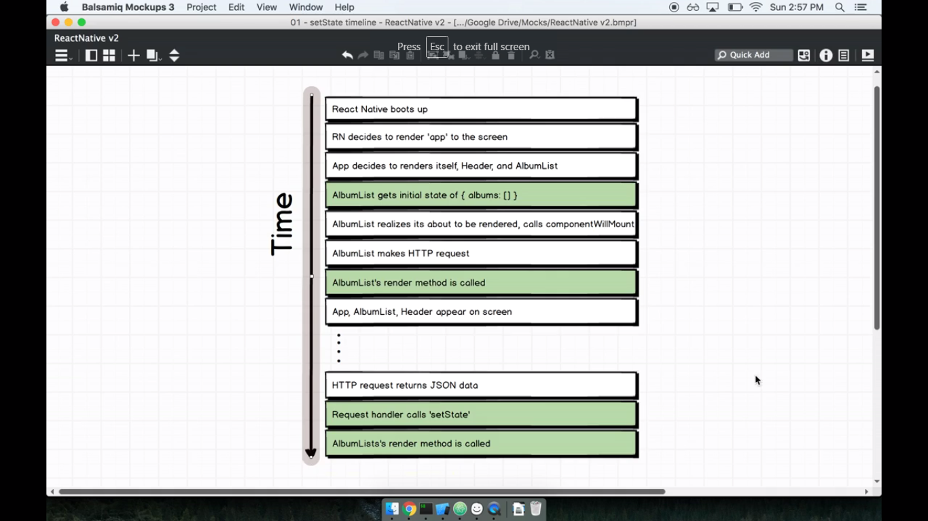

class AlbumList extends Component {

//set default or initial state

state = { albums: [] };

componentWillMount () {

axios.get('https://rallycoding.herokuapp.com/api/music_albums')

.then(response => this.setState({ albums: response.data }));

}

render() {

console.log(this.state);

return (

<View>

<Text>Album List!!!</Text>

</View>

);

}

}

**\* Rules of State**

1. Definition of State : a plain javascript object used to record and respond to user-triggered events.

2. When we need to update what a component shows, call 'this.setState'

3. Only change state with 'setState', do not do 'this.state = 123'

**\* Difference between props and state**

1. Whenever we want to communicate from Parent component to child component, use 'props'.

2. 'State' is for a component's internal record keeping, whenever we want to update data.

20)

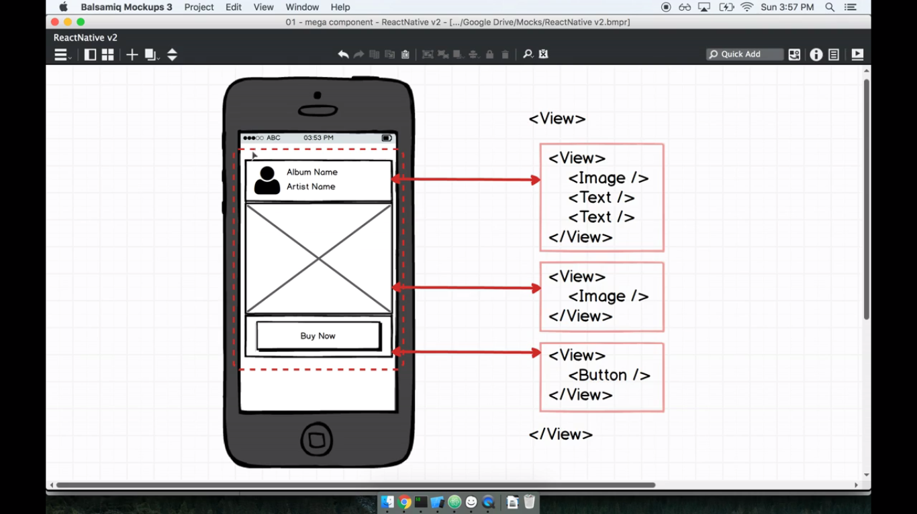

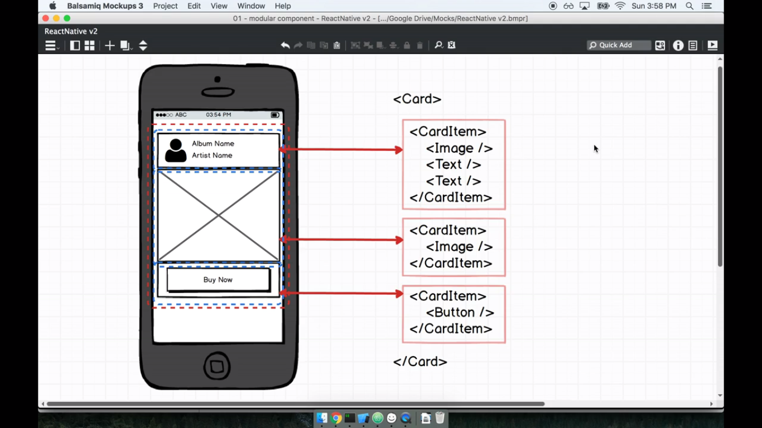

23) Mastering Layout with Flexbox

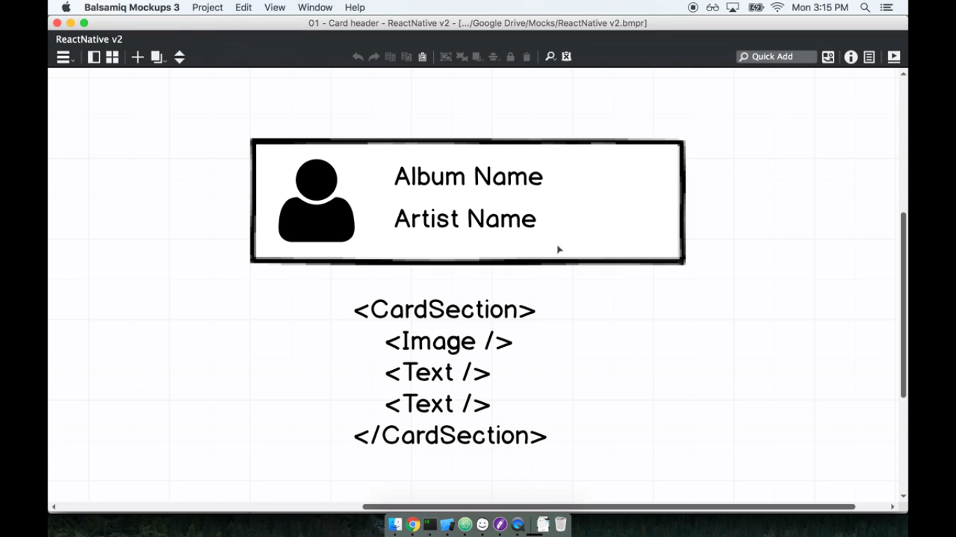

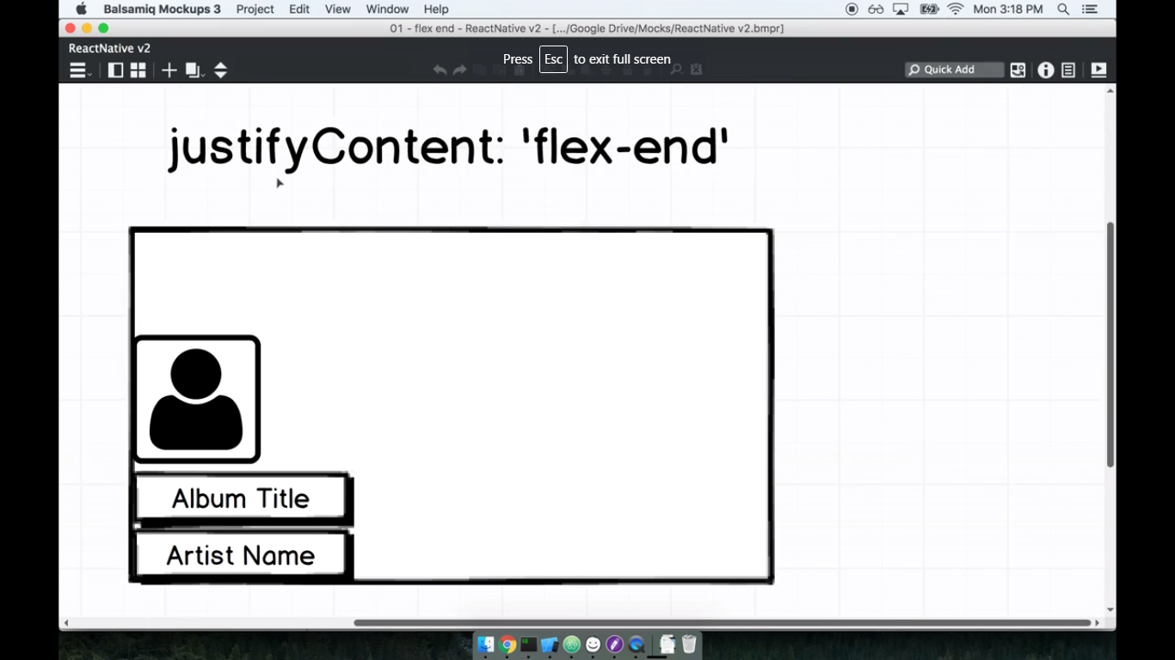

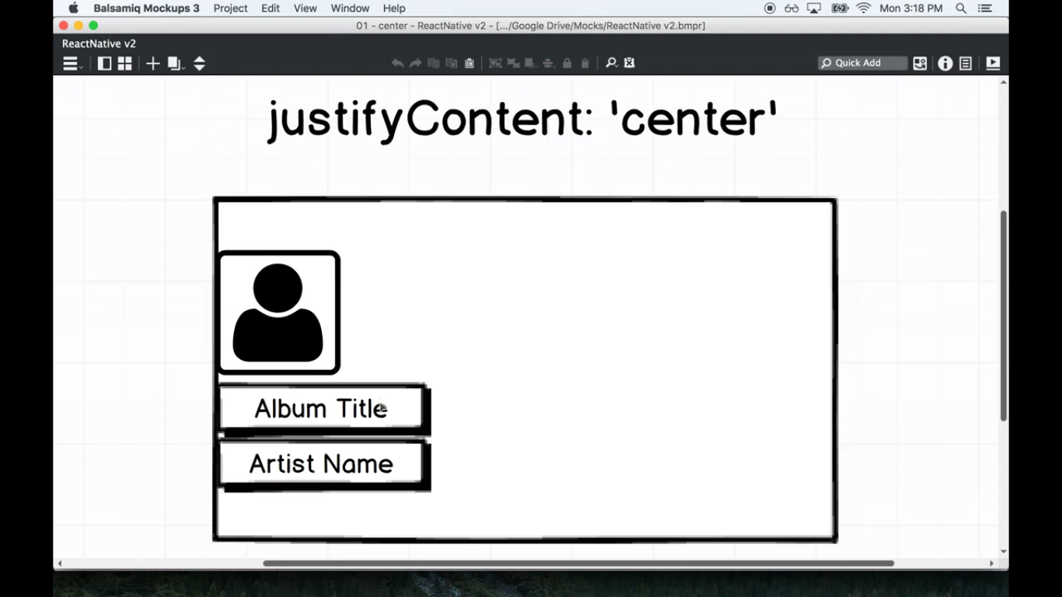  
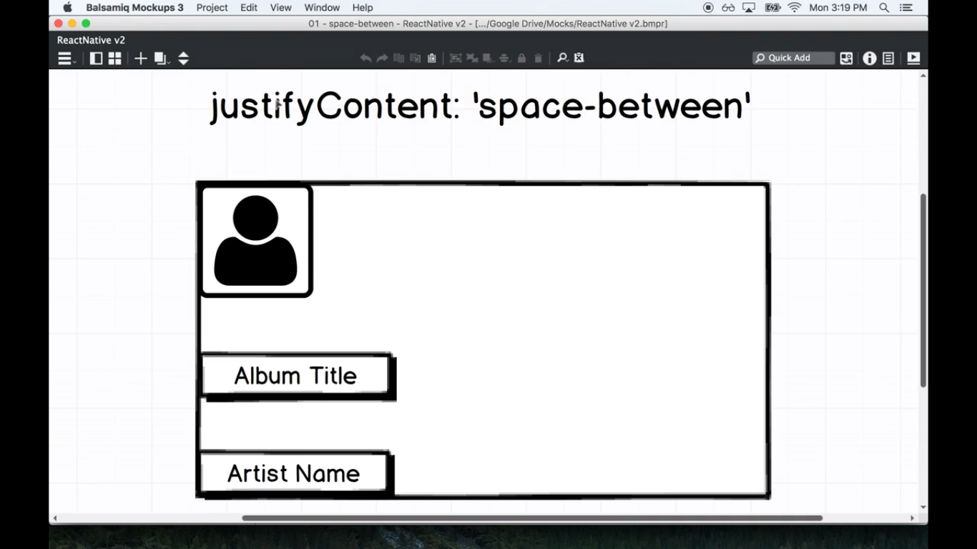

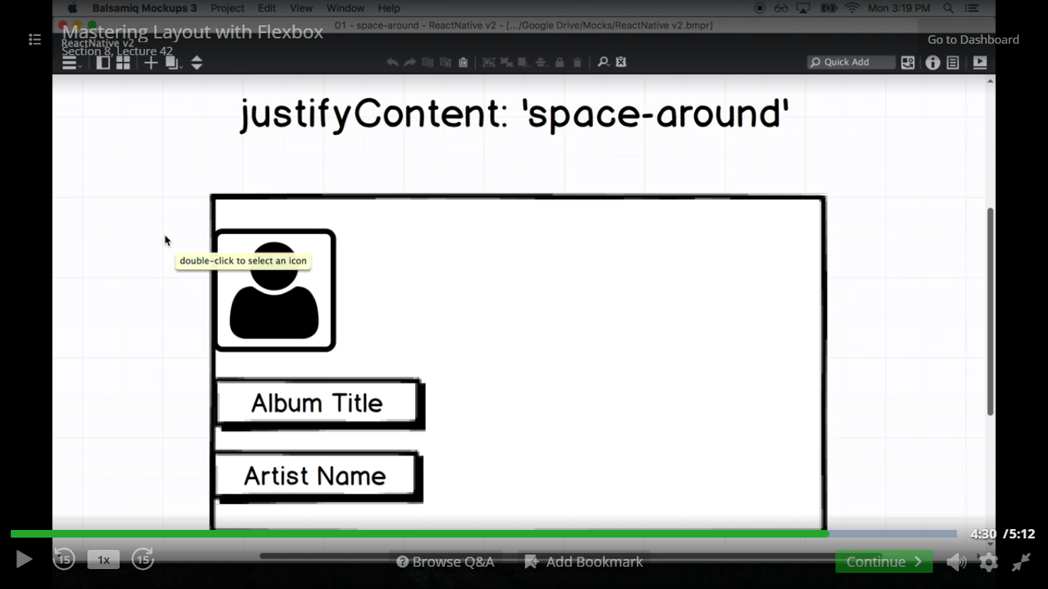

24) Positioning of Elements on Mobile

